**Project Design Phase-II**

**Technology Stack (Architecture & Stack)**

|  |  |
| --- | --- |
| Date | 03 October2022 |
| Team ID | PNT2022TMID30006 |
| Project Name | Cloud Computing –Nutrition Assistant |
| Maximum Marks | 4 Marks |

**Technical Architecture:**

The Deliverable shall include the architectural diagram

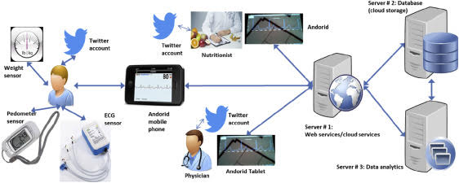

**FLOW DIAGRAM:**

